24-HOUR CLOCK

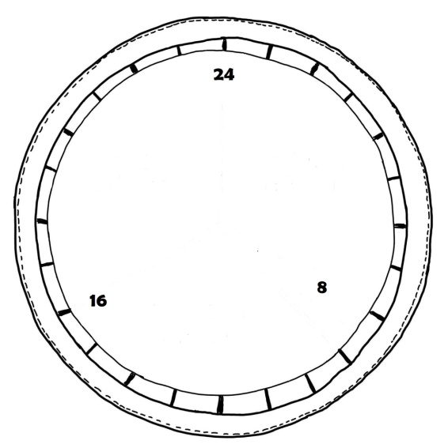

WELL-BEING SCORECARD

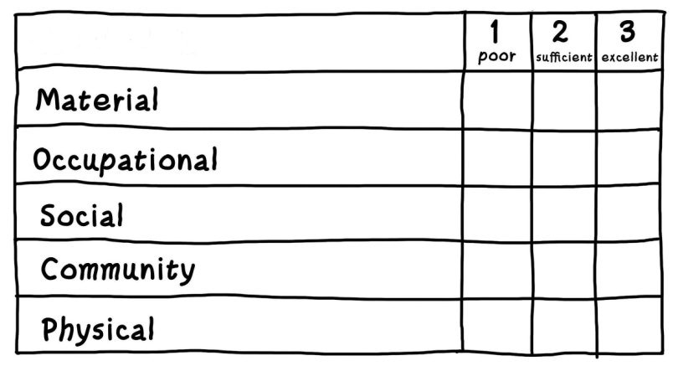

BALANCE SCALE
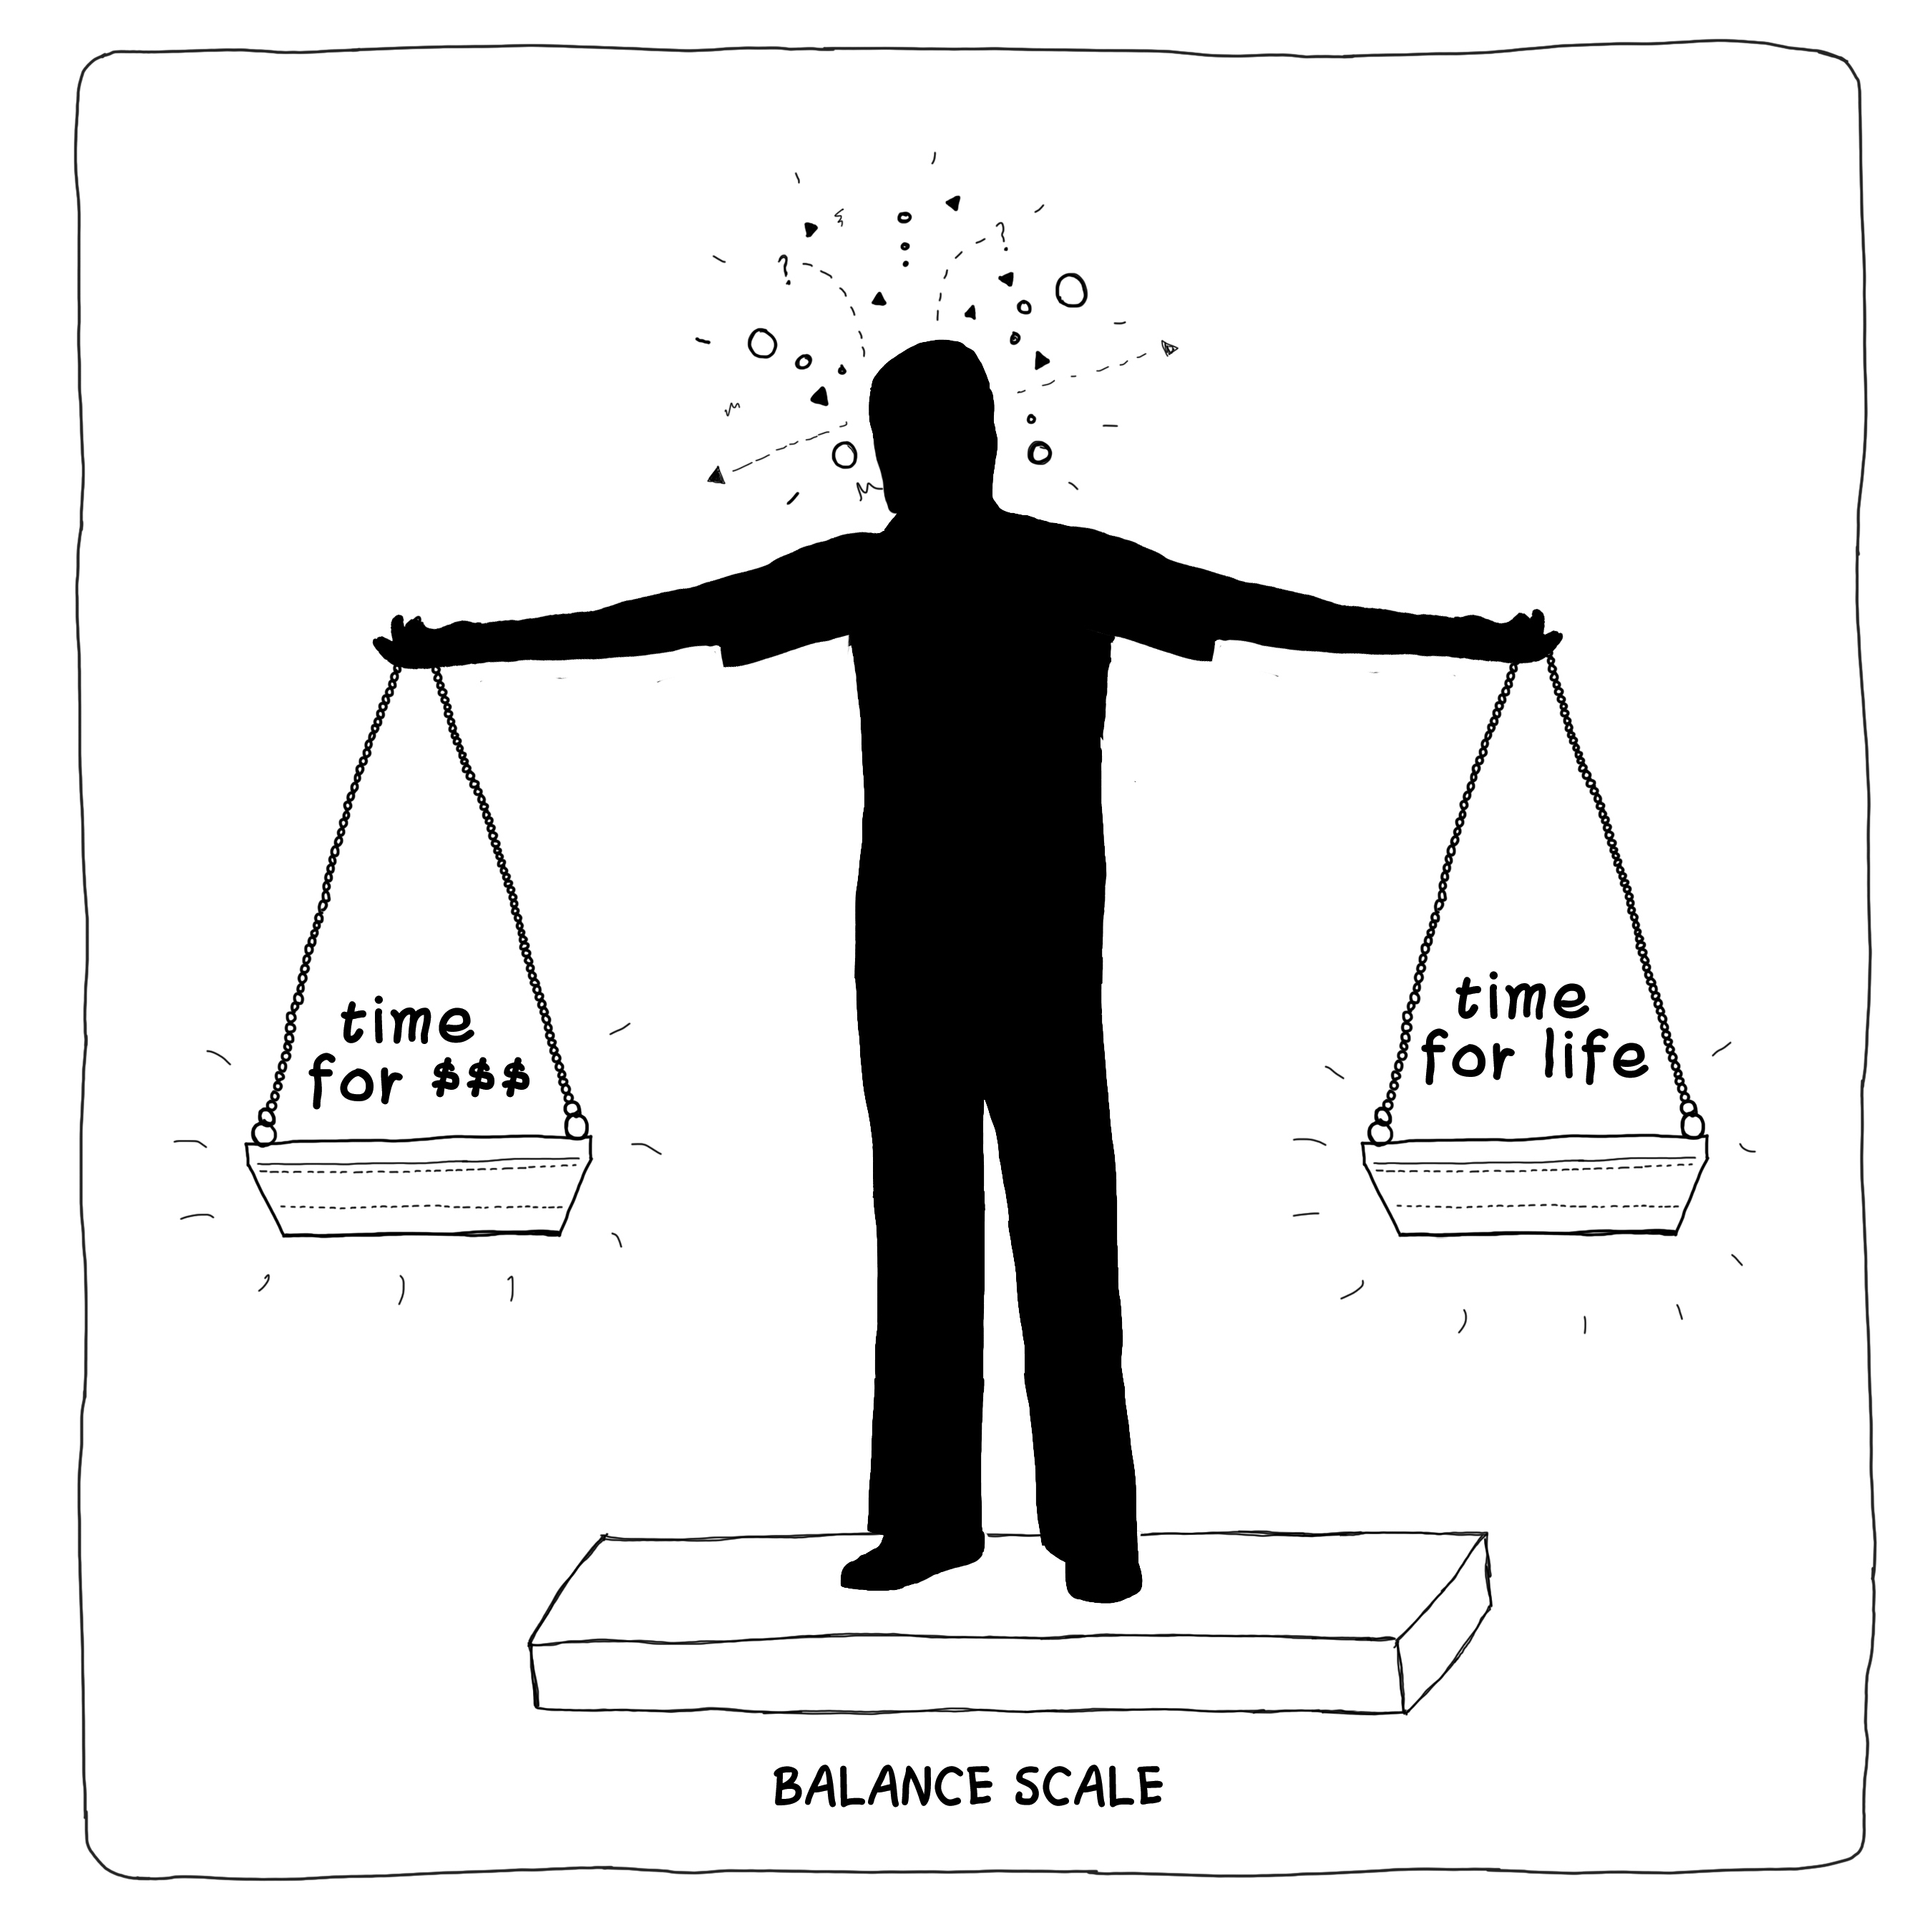

INDIVIDUAL AND PLANETARY WELL-BEING SCORECARD

