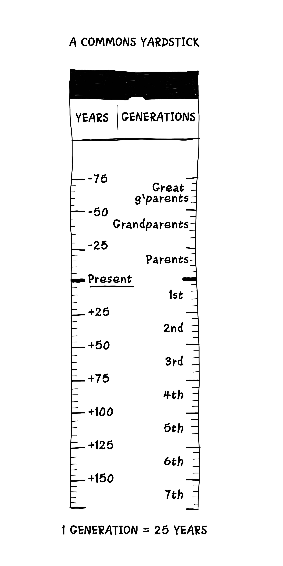

Access | Use | Benefit | Care | Responsibility | Ownership
Narrow | Restricted by owner | Private | Performed by owner or employee | Assumed by owner | Private individual  Private collective  State
Shared and wide | Negotiated by a community | Widely distributed to community and beyond | Performed by community members | Assumed by community | Private individual  Private collective  State  Open access
Unrestricted | Open and unregulated | Finders keepers | None | None | Open access  State

Creating new commons
Commoning unmanaged open-access resources
Commoning enclosed property

